SABANCI UNIVERSITY DSA 210 TERM PROJECT FINAL REPORT
ARINÇ ESKİCİOĞLU 34320

Champions league Success Predictor

- Abstract
This study mainly tries to formulate and evalueate success of teams in champions league from the data’s of champions league group stage by using data science techniques. In other words, one will be able to predict which teams have the probability to be the champion or the teams that are going to be on the top or bottom. Through statistical tests and supervised machine learning models, including linear regression, decision trees, and random forests, the analysis reveals that success in champions league may not be just coincidence but an outcome of qualified game and planning.

- Data to be used
- group stage game statistics
- total goals scored
- Number of wins in group stage
- Number of losses in group stage
- total goals scored against them
- Points they get in group stage
- xG (Expected goals)
- xGA (expected goals allowed)
- xGD/90 (Expected goal difference per 90 mins)

- market value of the teams
- how far they can get in champions league

- MOTIVATION AND WORKFLOW
Although I am not really into football, I sometimes feel that the results—especially in the Champions League and the Turkish Super League—are quite predictable, and the excitement seems unnecessary. It is common knowledge that if you pay 100M euros for a player, or if you are a team like Fenerbahçe or Galatasaray in the Super League, you are much more likely to win the trophy compared to others. Consequently, I realized that this dominance should also be reflected in gameplay statistics. A talented squad and a dominant game usually indicate early on that a team will go far in the tournament. Therefore, I wanted to compare the gameplay of these teams to predict who would be successful.
First, I had to collect group matches data. I could not get data directly from OPTA because they wanted me to pay for it. Then, I got that data from FBREF which gets data of gameplay statistics from OPTA. OPTA is known to be a trustable website. I get the elimination steps in champions league webpage and maret values from Wikipedia.
I was thinking of using average age of teams. However, it would maket he situation really complicated. There were teams using players that are 18-23 but they do not give them chance or just let them play for last 5 mins of the game or so. So that does not make really sense.
I am not using datas of knockout phase since it would not be prediction, it would be just shwoing results. It is too easy to say who is going to be successful knowing how the game goes. On the contrary, we have to say that that way would be more accurate, obviously.
This part is very important, I know that using teams that are eliminated in group stage is a bit confusing, since they have the same success score 0. But it was crucial to see what makes a team unsuccessful therefore i had to use them as well. Otherwise, especially in machine learning part, the model cannot what makes a team very unsuccessful which leads to wrong results. In order to solve that problem, I use goal difference instead of points since goal difference does not directly help you go further. However, I sometimes get rid of them to make noise reduction. I’ll mention my approach again in those parts.

- Explotary Data Analysis

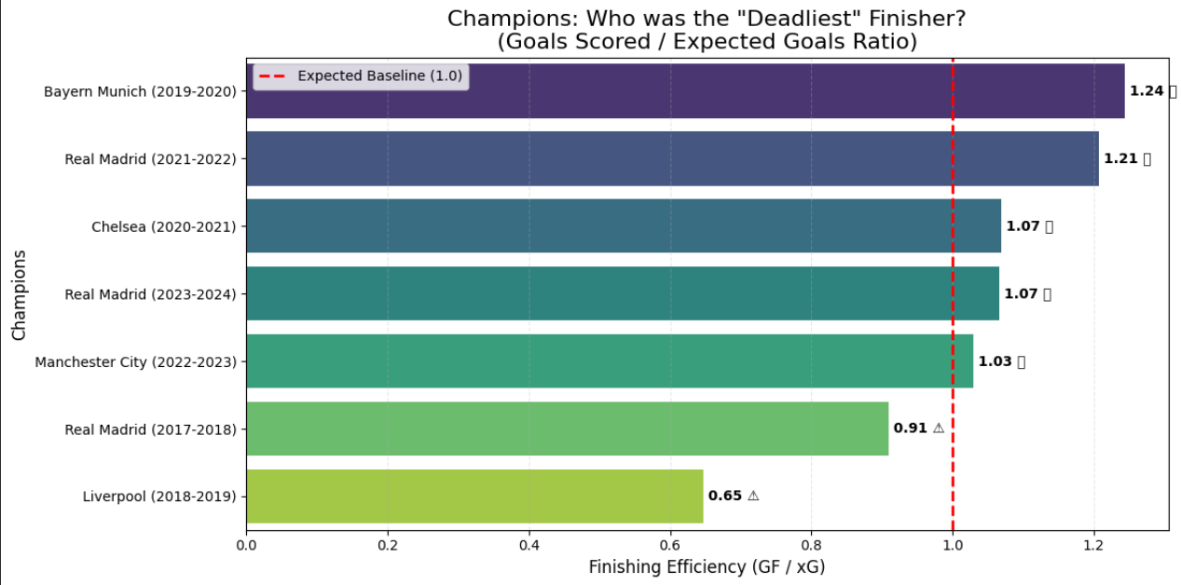
This comparison used the ratio between total goals and expected goals of champions of each year. If your ratio is above 1.0, it means your attacking players scored more than they were expected. And vice versa. This study reveals that, generally speaking, champions have good attacking players. But is it the thing that makes them champion? We’ll come to that point in hypothesis testing part as well.

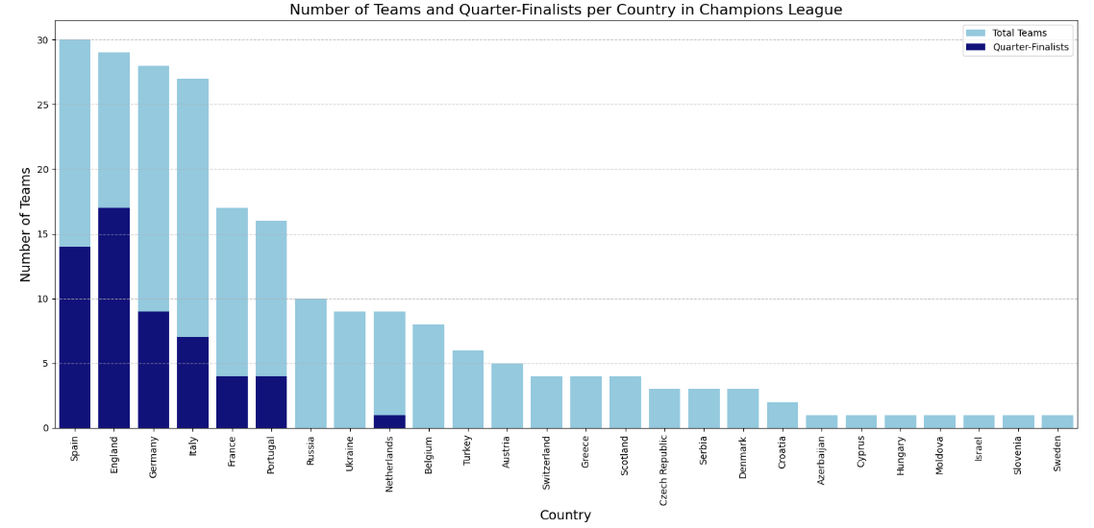
The bar chart illustrates the total number of Champions League teams per country, alongside the number of teams that reached at least the quarter-final stage to evaluate success rates. The data reveals that England is the most successful nation in terms of quarter-finalists, surpassing Spain, despite Spain having a higher total number of participating teams. Furthermore, it is noteworthy that countries with fewer than 10 participating teams generally failed to reach the quarter-finals, with only a single exception.

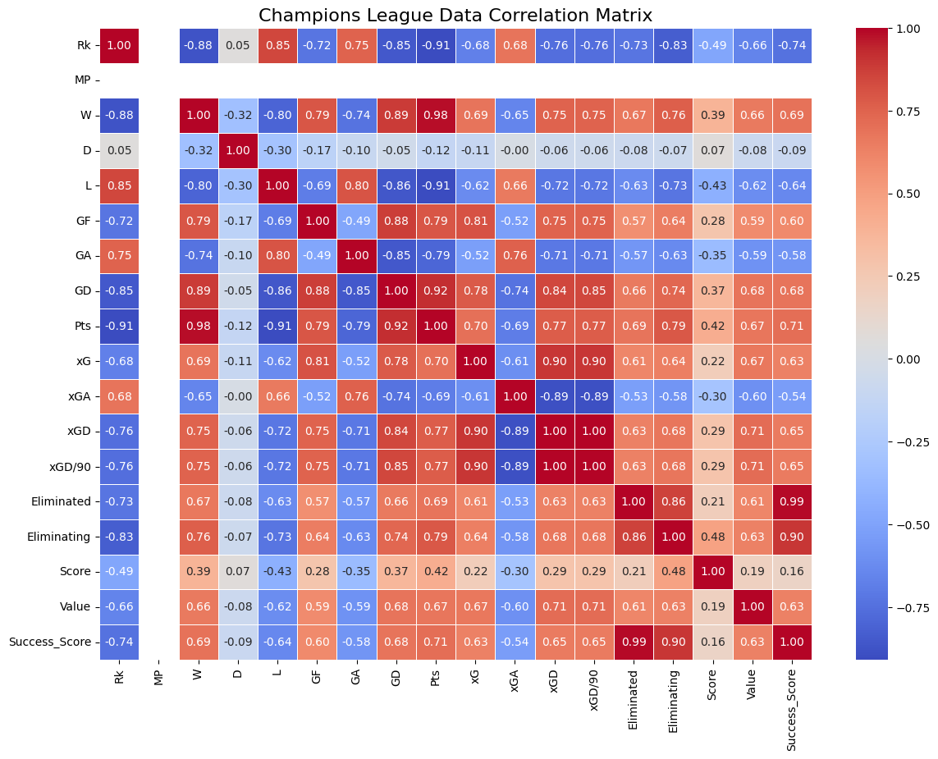
Understanding of correlation matrix is really impotant to see which data could be used in following hypothesis testing and machine learning analysis. Note that some variables are correlated which is a problem in linear regression models. For example, using both xGA and xGD can cause problems since xGD is calculated in the equation xGD = xG – xGA. They are strictly correlated and they cause models show wrong results. Therefore, instead of using xG and xGA, I used xGD or the same for GD.

The nice interpretations are value is correlated with xGD/90, wins in groups and elimination step.

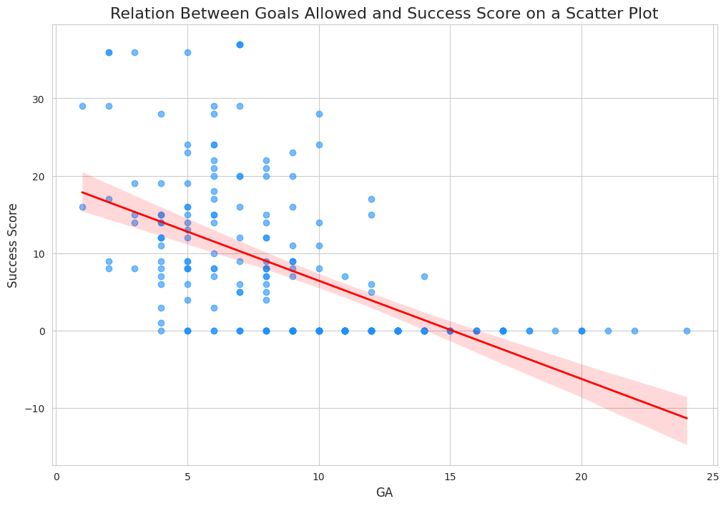
Or one can see the relation between goals allowed and success score on this scatter plot. One can see the negative correlation. There is no successful teams allowing more than 15 goals and teams having success score > 25 are below 7-8.

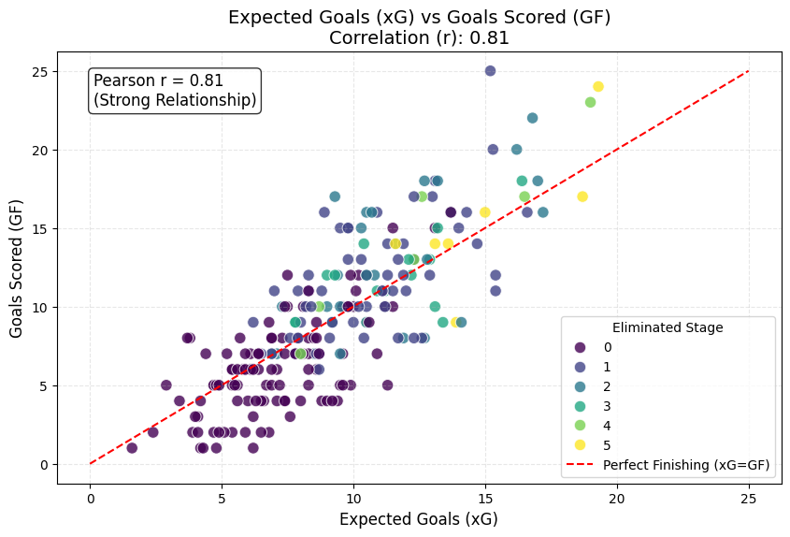
Here, one can investigate the luck factor for scoring goal by pearson correalation. Generally, the more you create chance the more you score. Moreover, teams that create more chance eliminated did not eliminated in early stages. It can be seen that on down left the darker spots are located more.

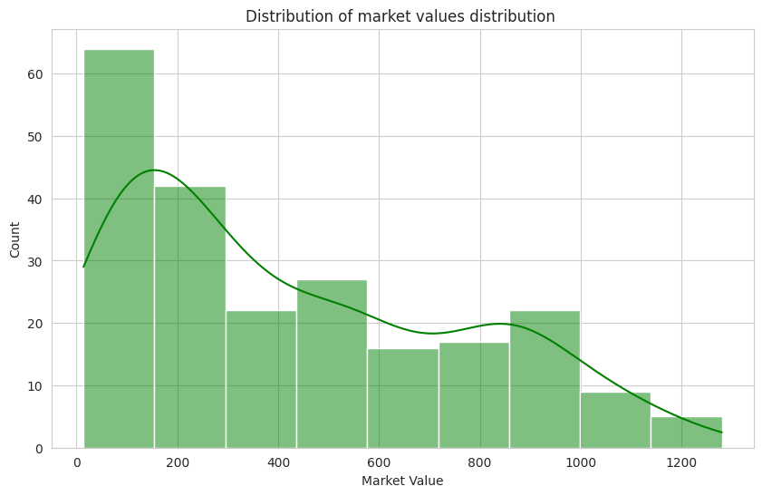
This graph shows number of teams from each market value, not that it is left skewed, which means most of the teams do not have very high market values. And graph is unimodal, there is one peak value.

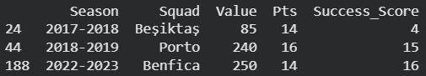
These are the outliers to be mentioned. They are so called “dark horses” their market values were low, but they managed to get good points from the groups.

- Hypothesis Testing

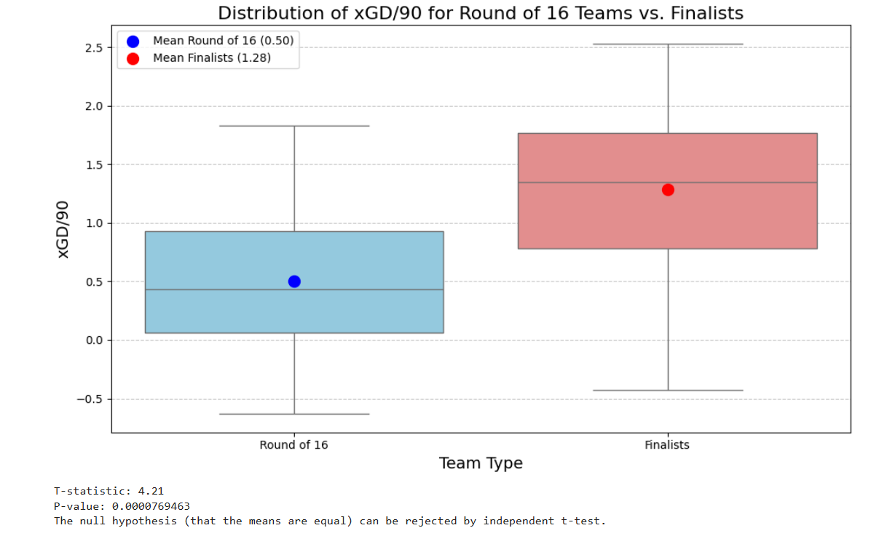

Null Hypothesis: There is no significant difference of expected goal difference in early group stage between finalists and teams that are eliminated in round of 16.
Alternative Hypothesis: There is difference of expected goal difference in early group stage between finalists and teams that are eliminated in round of 16.
Independent T-test: 4.21
P-value: 0.0000769463 which is < 0.05
Null hypothesis is rejected by independent t-test.
There is enough evidence to conclude that there is significant difference in terms of expected goal difference in early group stage between finalists and teams.

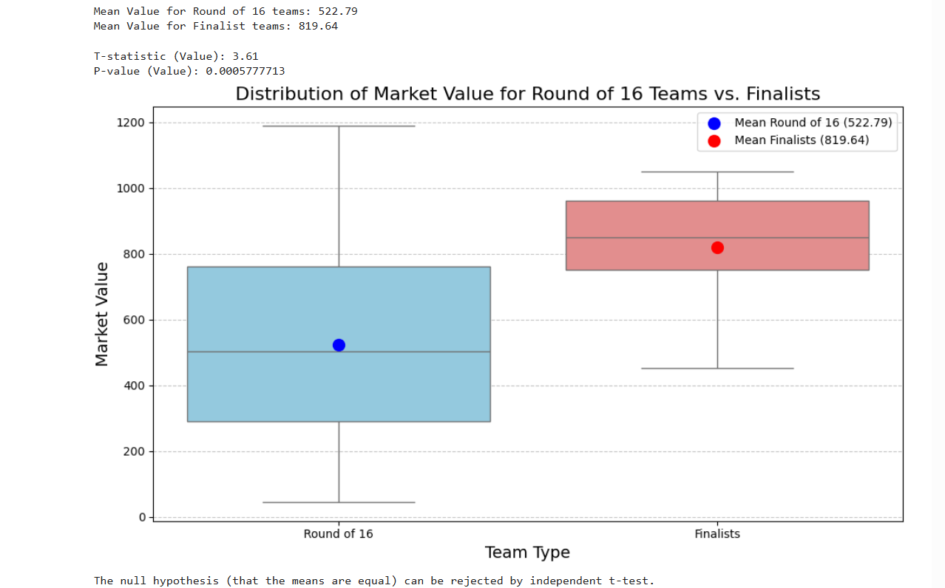

Null Hypothesis: There is no significant difference of market values between finalists and teams that are eliminated in round of 16.
Alternative Hypothesis: There is significant difference of market values between finalists and teams that are eliminated in round of 16.
Independent t-test: 3.61
P- value: 0.0058
Null hypothesis is rejected by independent t-test.
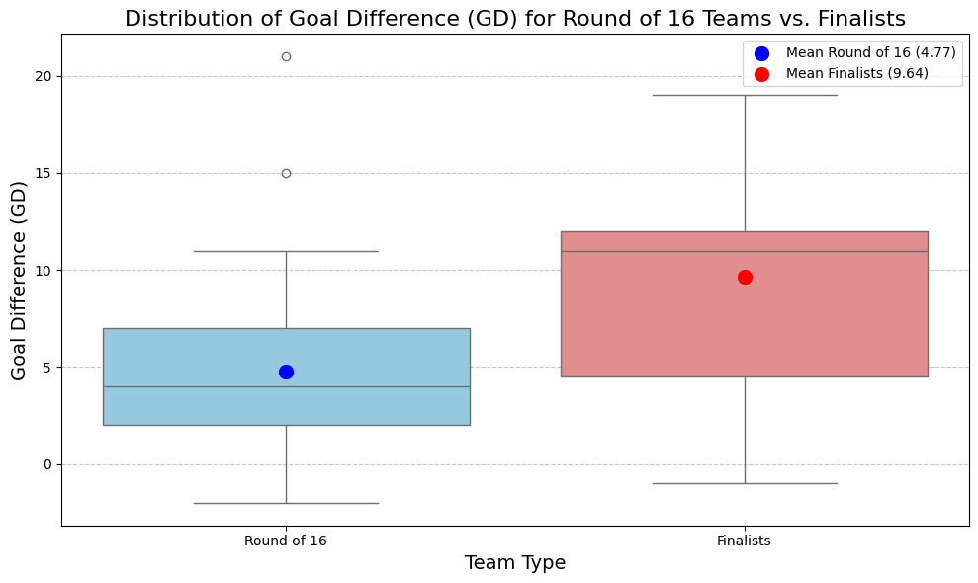
Null hypothesis: Goal difference of Finalists are not more than teams that are eliminated in round of 16.
T-statistic (GD): 3.53
P-value (GD): 0.0007526411
P-Value < 0.05. Null hypothesis is rejected.

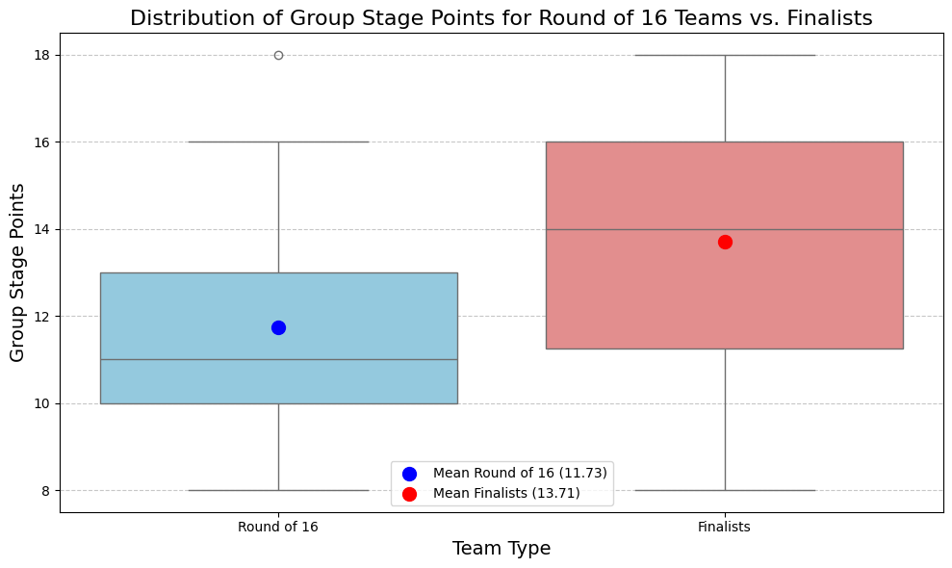
Null Hypothesis: Group stage point of champions are not more than group stage points of teams that are eliminated in round of 16.
The null hypothesis (that the means are equal) can be rejected by independent t-test.
T-statistic (Pts): 2.66
P-value (Pts): 0.0096509695 < 0.05.

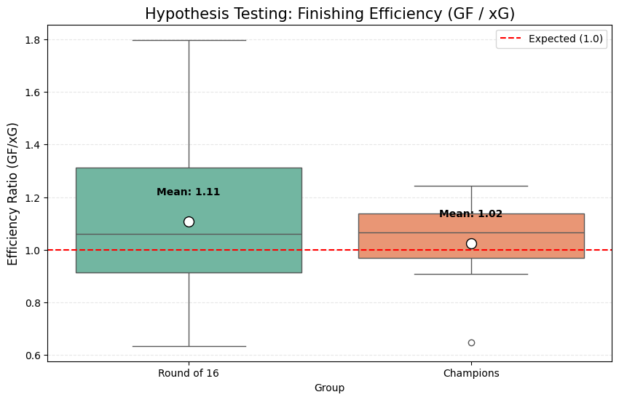
Null Hypothesis: Champion’s finishing score is not more than teams that are eliminated in round of 16.
Hypothesis testing is not needed. The the goal / goal expectancy of champions is lower than teams eliminated in round of 16.
Null hypothesis is correct.

- Machine Learning Analysis

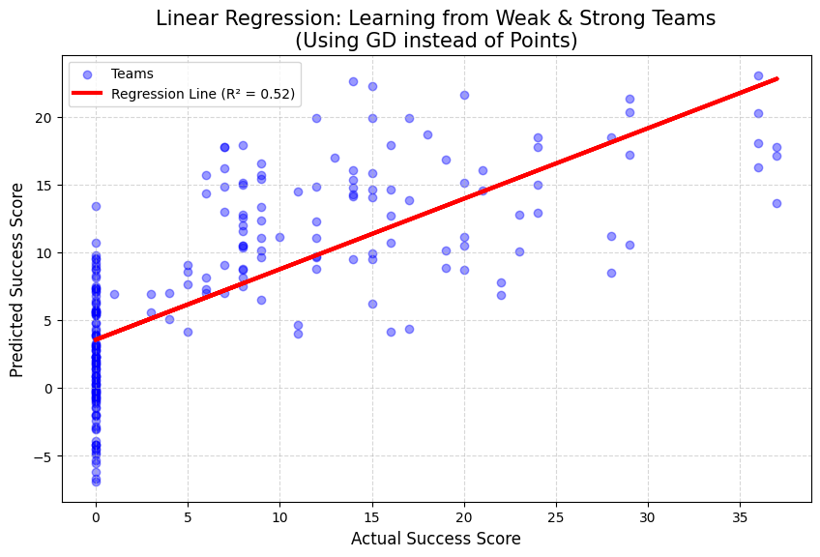

Success_Score = 3.82 + (0.45277 * GD) + (0.00830 * Value) + (1.31454 * xGD/90)
R^2 = 0.52 which means there is linear regression is %52 correct in predicting success.

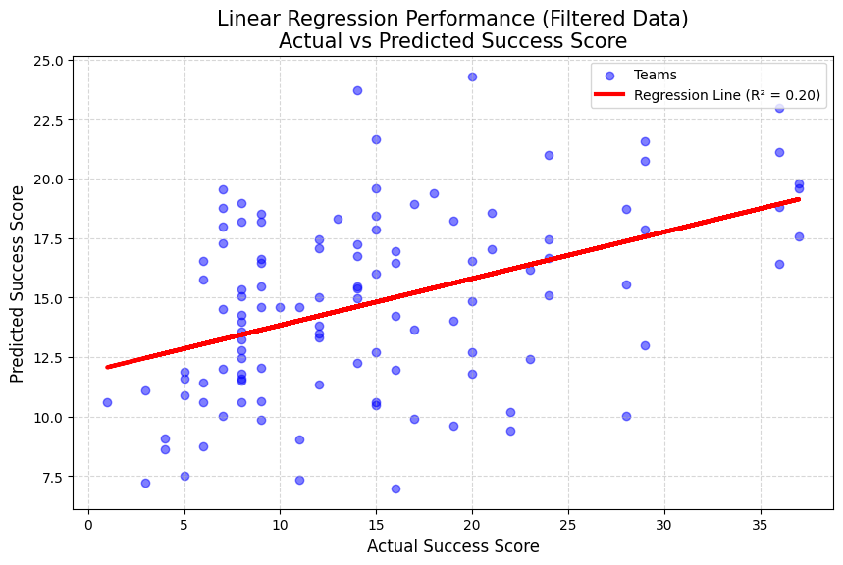
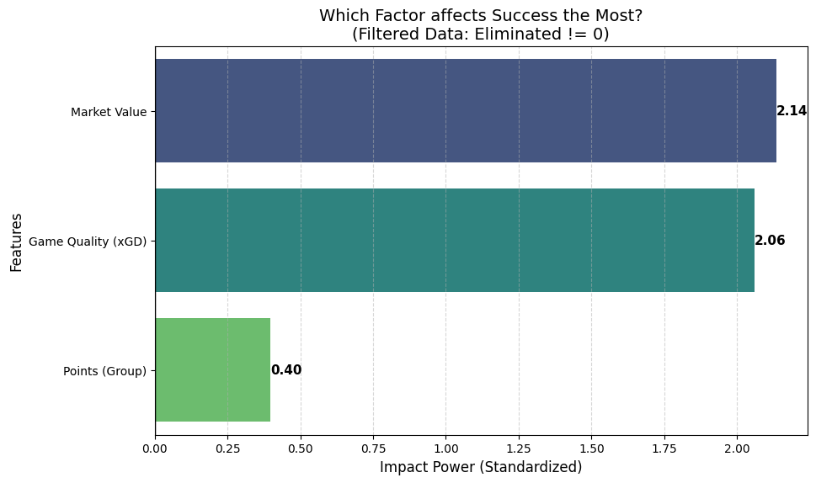
I also used Linear regression model for teams that managed to pass group stage. Here one can see that Points is nt really important and regreesion value is lower %20 since model does not evaluate really unsuccesfull teams.

Random Forest
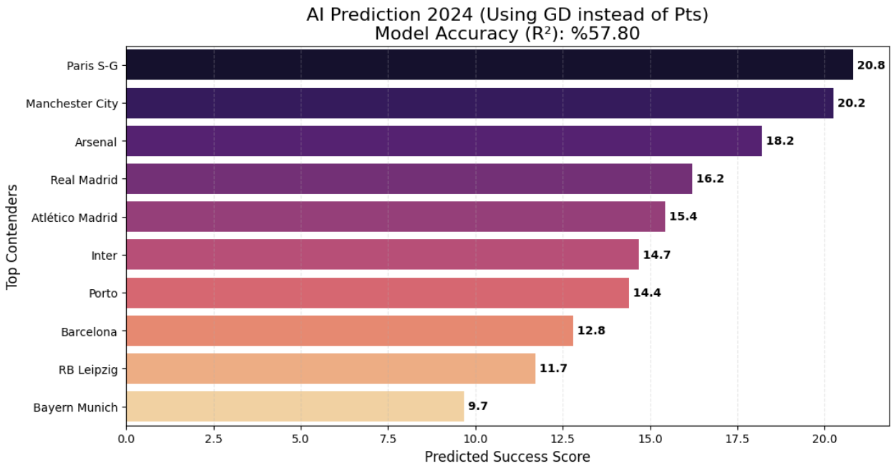
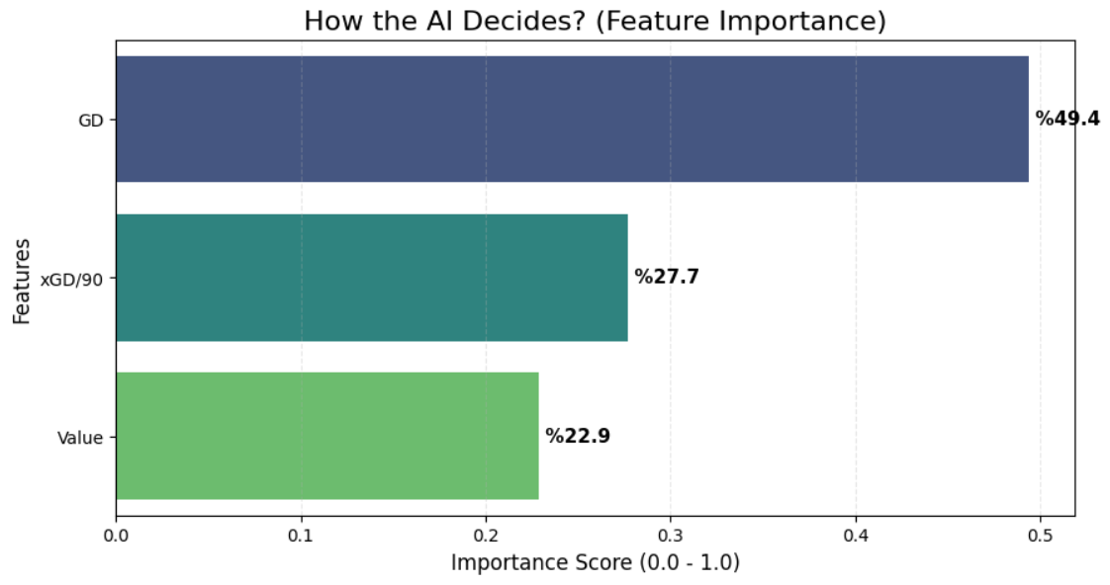
Here is the random forest model to predict champion of 2023-24 season. It has the R^2 value %57.80. Under that İt shows what measures are used modeling random forest. And the below graph is showing feature importance. The values are standardized since while market values can take values between 10M to 1B, xGD/90 takes values between -2 to 2. It demonstrades that Goal difference in matches is really important to show success. Market value and expected goal difference per 90 mins are also have significant effects.
R^2 : %57.80
RMSE: 6.35

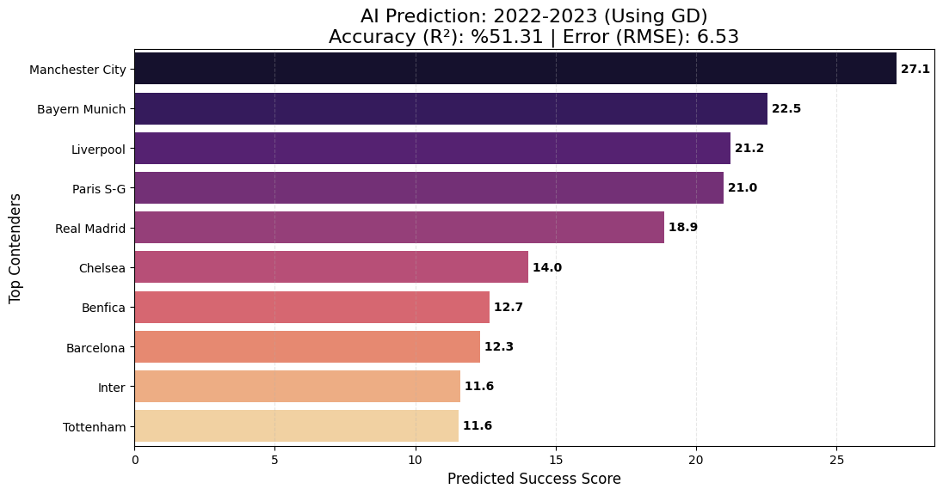

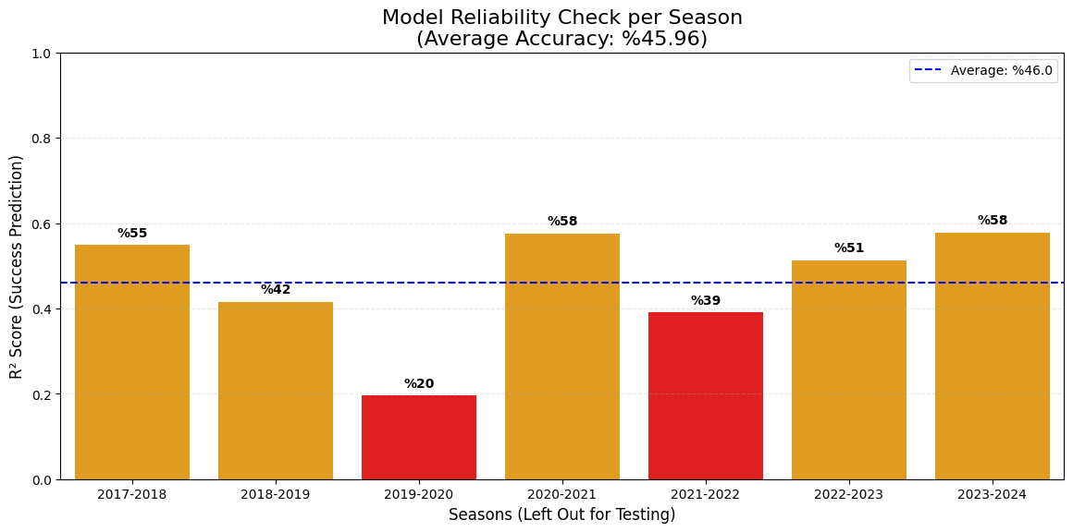
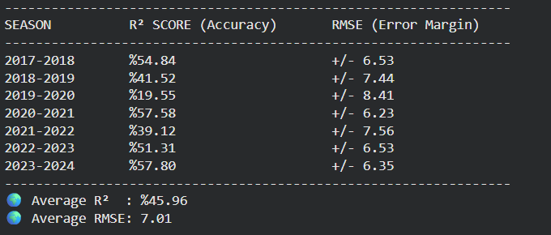
There is the bar chart shows results cross-validation to leave every each of them out one by one. One can see that R^2 values and RMSE values are consistent among the years. 2019-20 is low maybe because of Covid-19 and matches could not managed well.

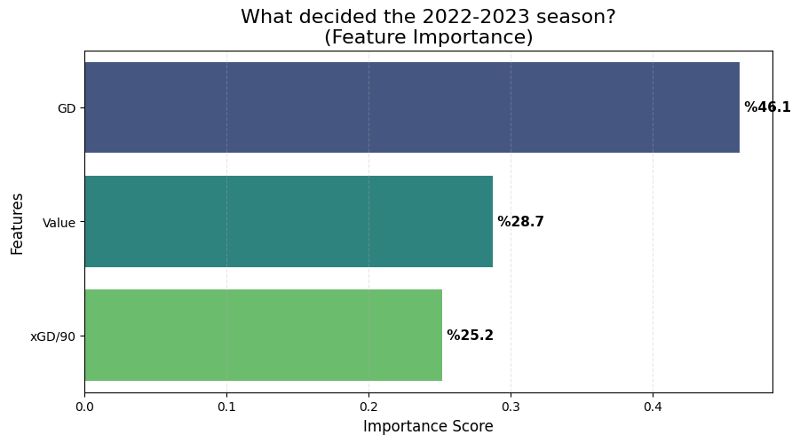
I also disregarded season 2022-23 and make a prediction accordingly to make cross validation. In this season, the champion is correctly predicted. Also the R^2 value is %51.31 which is close to the previous one.

Desicion Tree
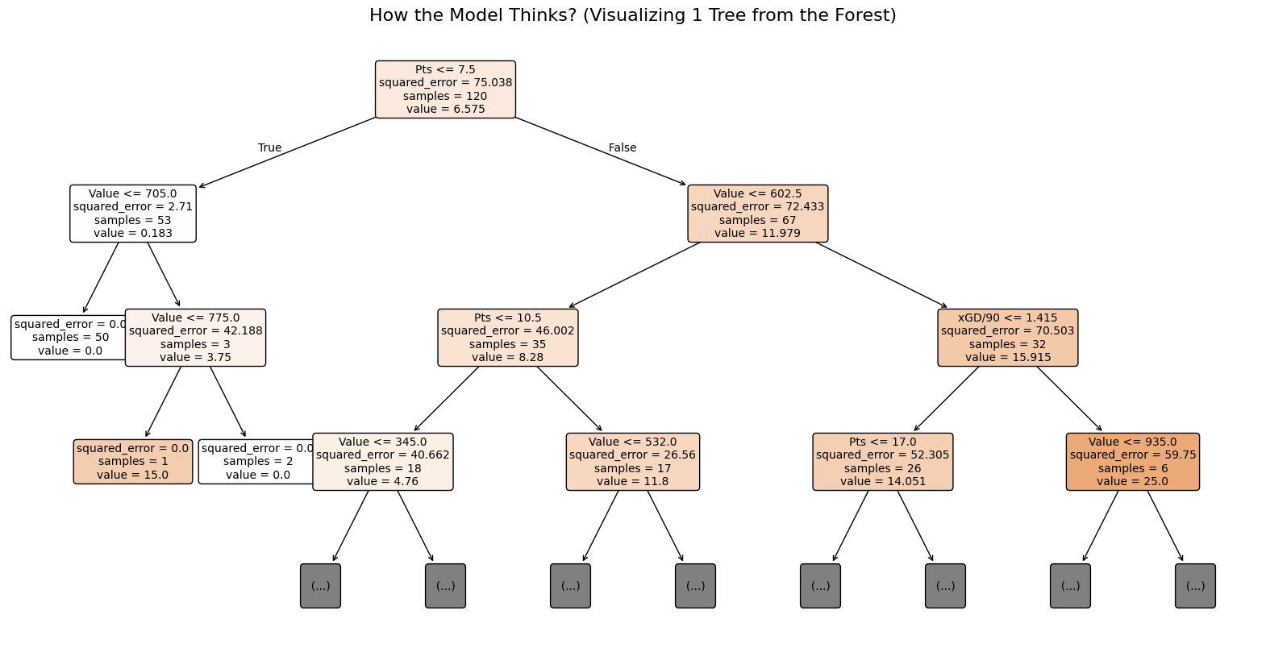
This is an example of a tree. One can see that points earned from gorup stage is really important since it determines whether you pass group stage or not.

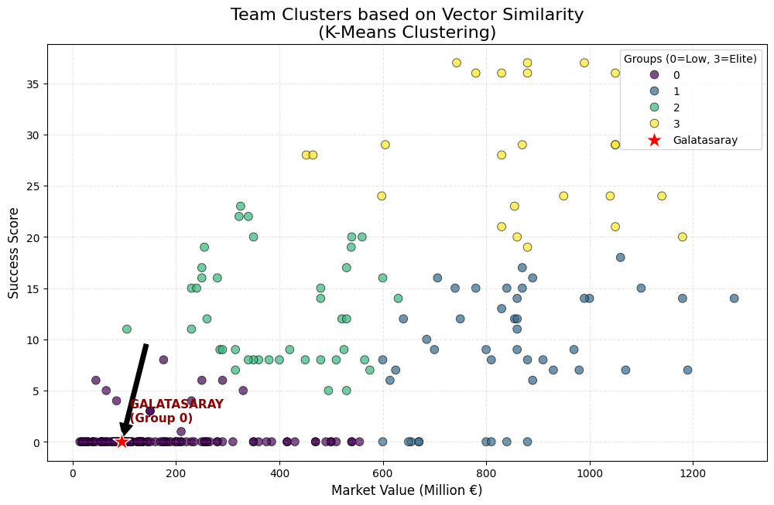
Here, k-means clustering is used for clustering. There are teams that have nice budgets but could not get too far. There are elite teams, poor teams and dark horses. In case someone wonder, I put where Galatasaray is. They are in group 0 and most similar teams with Galatasaray are APOEL FC, Atlético Madrid, RB Leipzig, Marseille, Inter.

